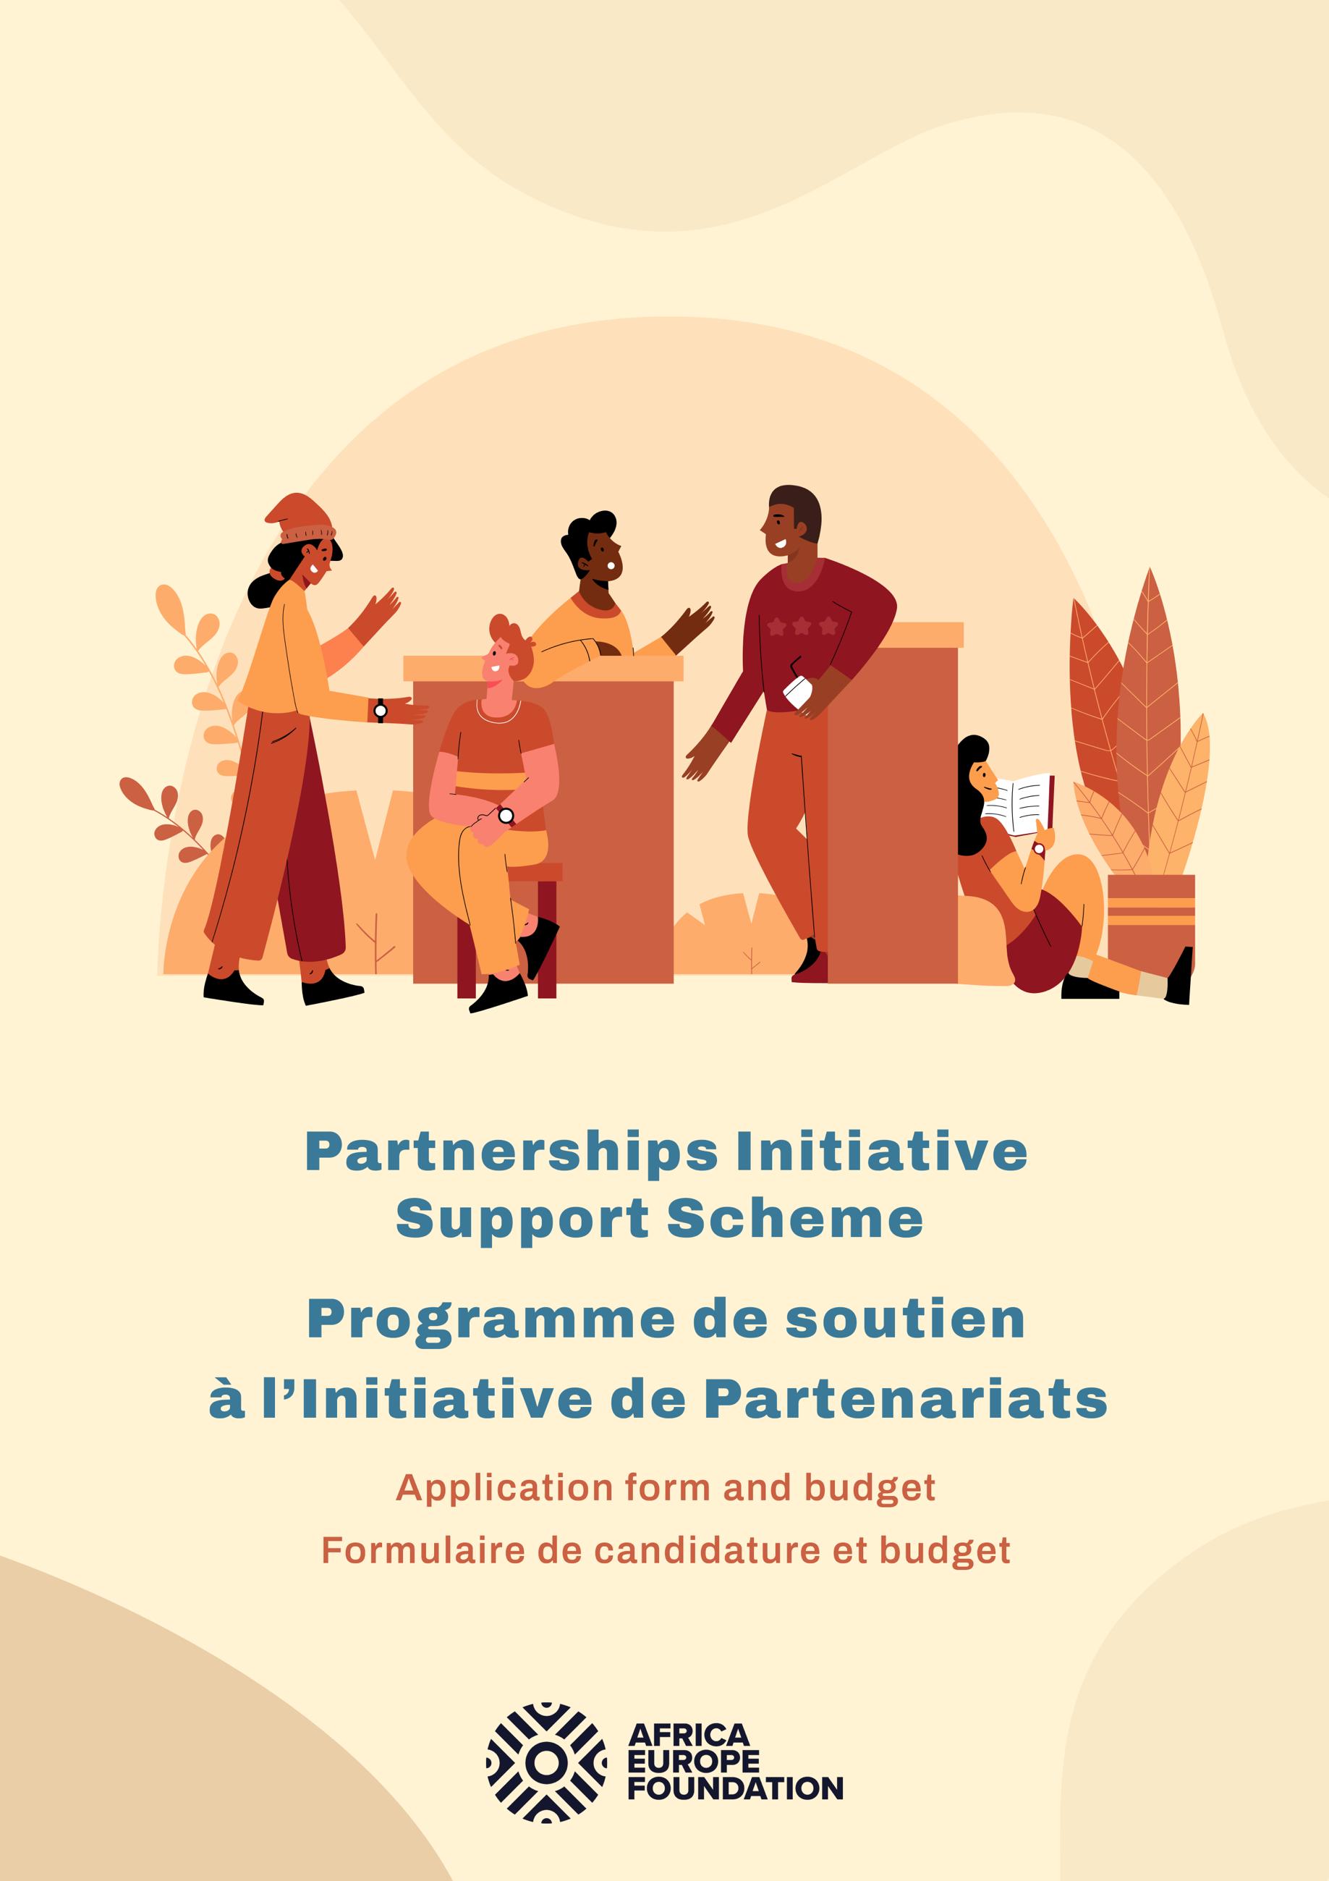

Africa-Europe Foundation
Partnerships Initiative Support Scheme
Application form and budget

Version française accessible à la page 4.

A 100-word (maximum) description of the youth organisation applicant (please also detail where your organisation is legally registered and where your application takes place)

Please confirm whether your organization is legally registered and if not if you have a registered legal fiscal partner who will be able to receive the award amount on your behalf (should you be using a fiscal partner please provide the name and details of the organization)

Contact details of legal representative of organization (Name, Surname, Email address, phone number with country code):

A 500-word (maximum) concept note of the activity (to include: context/background, main objective, target audience, format of activity):

A 200-word (maximum) description of the proposed impact of the activity including reach, main output, and timeline for the activity (note activities must take place by no later than Friday 29th September )

A 100-word (maximum) description of the financial proposal (breakdown of costs and any co-financing bodies):

Applicants are invited to fill in the following budget template, please note:
- Budget should include the direct costs to be funded through the AEF micro-award to the total of maximum €5,000;
- Successful applicants can co-finance their projects using multiple alternative financing streams;
- Budget should include co-financed elements.
 |  |  |  | Labour | Materials | Fixed costs | Co-Financing from other sources
Task | Description | Status | Start date
Subtask
Subtask
Subtask
SUBTOTAL |  |  |  | € | € | € | €

Please note that the sign-off of individual grants may be subject to the timing and regulations of AEF cooperation agreements with international donors.

